Table of contents

1. OLS and origin of heteroskedasticity
2. Heteroskedasticity
3. Volatility
4. ARCH/GARCH Models
5. Value at Risk
6. Limitations
7. Conclusion

**1) OLS and origin of heteroskedasticity**

OLS stands for Ordinary Least Squares, which is a method for estimating the parameters in a Multiple Linear Regression (MLR) model. A multivariate linear regression represents a relationship of proportionality between dependent(y) and multiple independent variables(xi) and is modeled as follows:

where i = 1,2,3,4 …. n,

The above linear regression model states that the expectation of the variable y is β times E(X) plus a constant α. The proportionality relationship between y and x is not exact but also contains an error ε. Standard regression theory assumes that the error ε has a zero mean and a constant standard deviation σ independent of all variables. The standard deviation is the square root of the variance, which is the expectation of the squared error:

It is a positive number that measures the size of the error.When the expectedsize of this error is constant and does not depend on the sizeof the variable x, we call this assumption, homoskedasticity.

**Heteroskedasticity**

Financial return data, in which the variances of the error terms are not equal, error terms may reasonably be expected to be larger for some points or ranges of the data than for others, are said to suffer from heteroskedasticity, which literally means “various dispersion” in ancient Greek. In the context of regression analysis, heteroskedasticity occurs when the variance of the errors (or residuals) is not constant across all levels of the independent variables. This violates one of the assumptions of ordinary least squares (OLS) regression, which assumes that the variance of the errors is constant (homoskedasticity).

Heteroskedasticity can lead to inefficient estimates of the regression coefficients. Standard errors and hypothesis tests based on these standard errors can become unreliable. If heteroskedasticity is present in your regression analysis, it can affect the validity of statistical inferences drawn from the model.

**Testing for Heteroskedasticity**

White test

Breusch-Pagan test

Goldfeld–Quandt test

**Volatility**

Volatility is a statistical measure of asset return dispersion across time used in finance. The standard deviation or variance of price returns is frequently used to calculate it. We’ll use the term “volatility” to refer to both standard deviation and variance in this course. Volatility is used to characterize the uncertainty surrounding the price movement of financial assets. It’s a crucial notion that is used in risk management, portfolio optimization, and other areas. It’s also one of the most active fields of empirical finance and time series analysis study. The risk and volatility of assets are directly proportional to each other which means the riskier a financial asset is, the higher the volatility.

Volatility is a response to the news which must be a surprise. However, the timing of the news may not be a surprise and gives rise to predictable components of volatility such as economic announcements. Volatility tends to rise or fall in a predictable pattern over time. Black (1976) first noted that changes in stock returns display a tendency to be negatively correlated with changes in returns volatility, i.e., volatility tends to rise in response to “bad news” and to fall in response to “good news”. This phenomenon is termed the “leverage effect”. We can observe the phenomenon of “leverage effect” by plotting the market prices and their volatility as below:

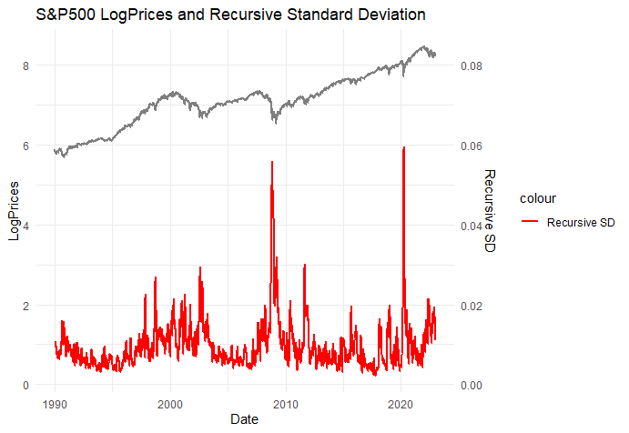

**Volatility Clustering**

In time series modeling, it’s a frequent assumption that volatility remains constant throughout time. Looking at financial data suggests that some time periods are riskier than others; that is, the expected value of the magnitude of error terms at sometimes is greater than at others. Moreover, these risky times are not scattered randomly across quarterly or annual data. Instead, there is a degree of autocorrelation in the riskiness of financial returns. Financial analysts, looking at plots of daily returns such as in Figure 1, notice that the amplitude of the returns varies over time and describe this as “volatility clustering.” The ARCH/GARCH models, which stand for autoregressive conditional heteroskedasticity and generalized autoregressive conditional heteroskedasticity, are designed to deal with just this set of issues. The goal of such models is to provide a volatility measure – like a standard deviation -- that can be used in financial decisions concerning risk analysis, portfolio selection, and derivative pricing.

Modeling and predicting the volatility of financial assets, such as the S&P 500 index, is an important task in quantitative finance and is crucial for risk management, derivatives pricing, and portfolio optimization.

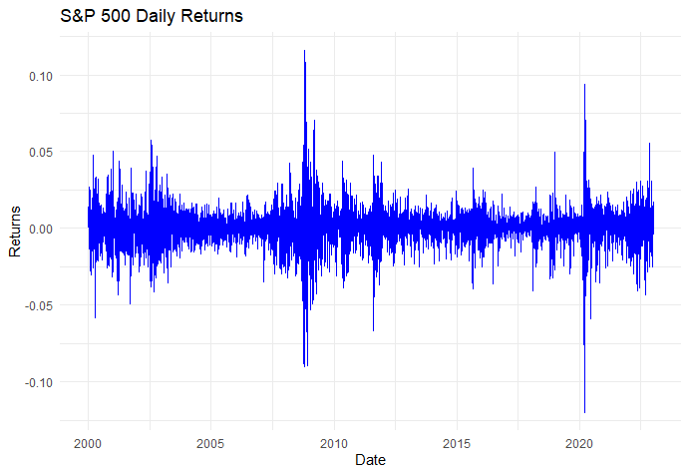

**ARCH/GARCH Models**

There is an increasing need to forecast and analyze the size of the errors of the model. Instead of considering this as a problem to be corrected, ARCH and GARCH models treat heteroskedasticity as a variance to be modeled. As a result, not only are the deficiencies of least squares corrected, but a prediction is computed for the variance of each error term. Modeling time-varying volatility and correlation in financial time series is an important element in pricing equity, risk management, and portfolio management. Higher volatilities increase the risk of assets and higher correlations between assets cause an increased risk in portfolios.

ARCH/GARCH models have been applied to model volatility with great success in capturing stylized facts of financial time series, such as time-varying volatility and volatility clustering. The Autoregressive Conditional Heteroskedasticity (ARCH) model was first introduced in the seminal paper of Engle (1982). Bollerslev (1986) generalized the ARCH model (GARCH) by modeling the conditional variance to depend on its lagged values as well as squared lagged values of disturbance.

In describing ARCH/GARCH behavior, it is emphasized that the errors are an innovation process and assume that the conditional mean of the errors is zero. The error process is written as:

where σt is the conditional standard deviation and the z terms are a sequence of independent, zero-mean, unit-variance, normally distributed variables. Under this assumption, the unconditional variance of the error process is the unconditional mean of the conditional variance. In financial and economic models, conditioning is often stated as regressions of the future values of the variables based on the present and past values of the same variable. For example, if we assume that time is discrete, we can express conditioning as an autoregressive model:

The error term is conditional on the information that, in this example, is represented by the present and the past n values of the variable X.

The ARCH/GARCH specification of errors allows one to estimate models more accurately and to forecast volatility. Let the dependent variable, which might be the return on an asset or a portfolio, be labeled *rt*. The mean value and the variance *h* will be defined relative to a past information set.

The challenge is to specify how the information is used to forecast the mean and variance of the return conditional on the past information. The simplest strategy to capture the time dependency of the variance is to use a short rolling window for estimates.

The simplest way is to use rolling standard deviation. This is the standard deviation calculated using a fixed number of the most recent observations. For example, this could be calculated every day using the most recent quarter (i.e., 66 days) of data. It is convenient to think of this as the first ARCH model; it assumes that the variance of tomorrow’s return is an equally weighted average of the squared residuals from the last 66 days. The assumption of 1) equal weights and 2) zero weights for observations more than one month old seems unattractive. The ARCH model proposed by Engle (1982) let these weights be parameters to be estimated. Thus, the model allowed the data to determine the best weights to use in forecasting the variance.

In the original formulation of the ARCH model, the variance is forecasted as a moving average of past error terms:

where the coefficients must be estimated from empirical data. The errors themselves will have the form,

Thus, ARCH is a forecasting model as it forecasts the error variance at time *t* based on information known at time *t* − 1.

A useful generalization of this model is the GARCH parameterization introduced by Bollerslev (1986). This model is also a weighted average of past squared residuals, but it has declining weights that never go completely to zero. In its most general form, it is not a Markovian model, as all past errors contribute to forecast volatility. It gives parsimonious models that are easy to estimate and, even in its simplest form, has proven surprisingly successful in predicting conditional variances. The most widely used GARCH specification asserts that the best predictor of the variance in the next period is a weighted average of

1) the long-run average variance,

2) the variance predicted for this period, ( )

3) the new information in this period that is captured by the most recent squared residual ().

Such an updating rule is a simple description of adaptive or learning behavior from past information. To be precise, we can use to define the variance of the residuals of a regression:

In this definition, the variance of is one. Therefore, a GARCH (1,1) model for variance looks like this:

The econometrician must estimate the constants . Then, updating simply requires knowing the previous forecast *h* and the residual. The weights are and the long-run average variance is it really works and makes sense only if the weights are positive, requiring , and

The GARCH model described above and typically referred to as the GARCH(1,1) model derives its name from the fact that the 1,1 in parentheses is a standard notation in which the first number refers to the number of autoregressive lags (or ARCH terms) that appear in the equation and the second number refers to the number of moving average lags specified (often called the number of GARCH terms). The process is quite straightforward: For any set of parameters and a starting estimate for the variance of the first observation, which is often taken to be the observed variance of the residuals, it is easy to calculate the variance forecast for the second observation. The GARCH updating formula takes the weighted average of the unconditional variance, the squared residual for the first observation, and the starting variance and estimates the variance of the second observation. This is input into the forecast of the third variance, and so forth. Eventually, an entire time series of variance forecasts is constructed.

**Value at Risk**

ARCH/GARCH models play a key role in Value at Risk calculations. VaR is a statistical measure used to quantify the level of financial risk within a firm's investments or portfolio. Specifically, the "1% Value at Risk," which represents the dollar amount that an institution can be 99% certain will not be exceeded in terms of losses on the next day. Using ARCH/GARCH models, financial institutions can estimate the potential losses (or gains) at different confidence levels, providing valuable insights into the risks faced by their portfolios.

**Results and Conclusion**

**Limitations**

when using GARCH models for financial analysis, especially in scenarios where asymmetric responses, non-symmetric distributions, and the interpretation of volatility shocks are critical considerations, researchers in the field of finance need to be aware of the following limitations:

if we were able to make conditional forecasts of returns, then the ARCH model describes the behavior of the errors and it is no longer true that the unconditional variance of errors coincides with the unconditional variance of returns. Thus, the statement that ARCH models describe the time evolution of the variance of returns is true only if returns have a constant expectation.

N**eglect of Volatility Asymmetry**: GARCH models assume that only the magnitude of unanticipated excess returns influences volatility, not their positivity or negativity. However, empirical evidence suggests that volatility tends to rise more sharply in response to bad news (negative excess returns) than to good news (positive excess returns). This suggests a limitation of GARCH models in capturing asymmetric responses to positive and negative shocks.

**Symmetric Distribution Assumption**: If the distribution of the error term zt is symmetric, the change in variance is uncorrelated with excess returns. This means that GARCH models assume that volatility changes are not influenced by the direction of excess returns (positive or negative). This assumption might not align with the observed behavior of financial markets.

**Nonnegativity Constraints**: GARCH models include constraints to ensure that the conditional variance remains nonnegative. While this ensures stability in the model, it limits the possibility of capturing certain types of random behavior in the variance process. Additionally, these constraints can complicate the estimation process.

**Difficulty in Estimation**: The nonnegativity constraints can lead to difficulties in estimating GARCH models. Researchers have had to impose specific structures on model coefficients to prevent them from becoming negative, indicating potential challenges in the estimation process.

**Interpretation of Volatility Shocks**: GARCH models are used to analyze the persistence of shocks to conditional variance. The duration for which these shocks persist is crucial in understanding their impact on asset pricing and investment decisions. Long-lasting volatility shocks can significantly influence risk premia and long-term investment strategies.